**Output showing the repository structure in my local directory:**

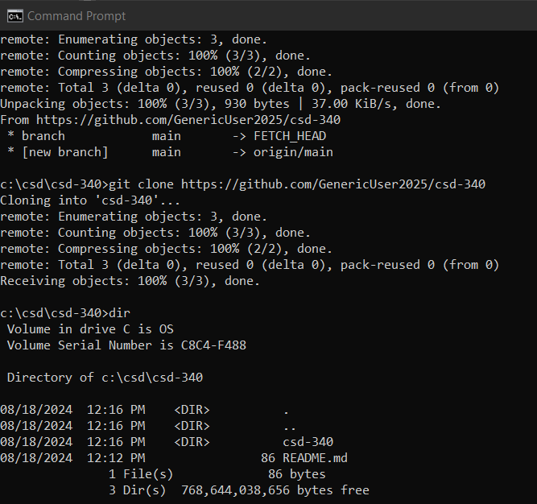

**Screenshot of GitHub Landing Page for Repository:**

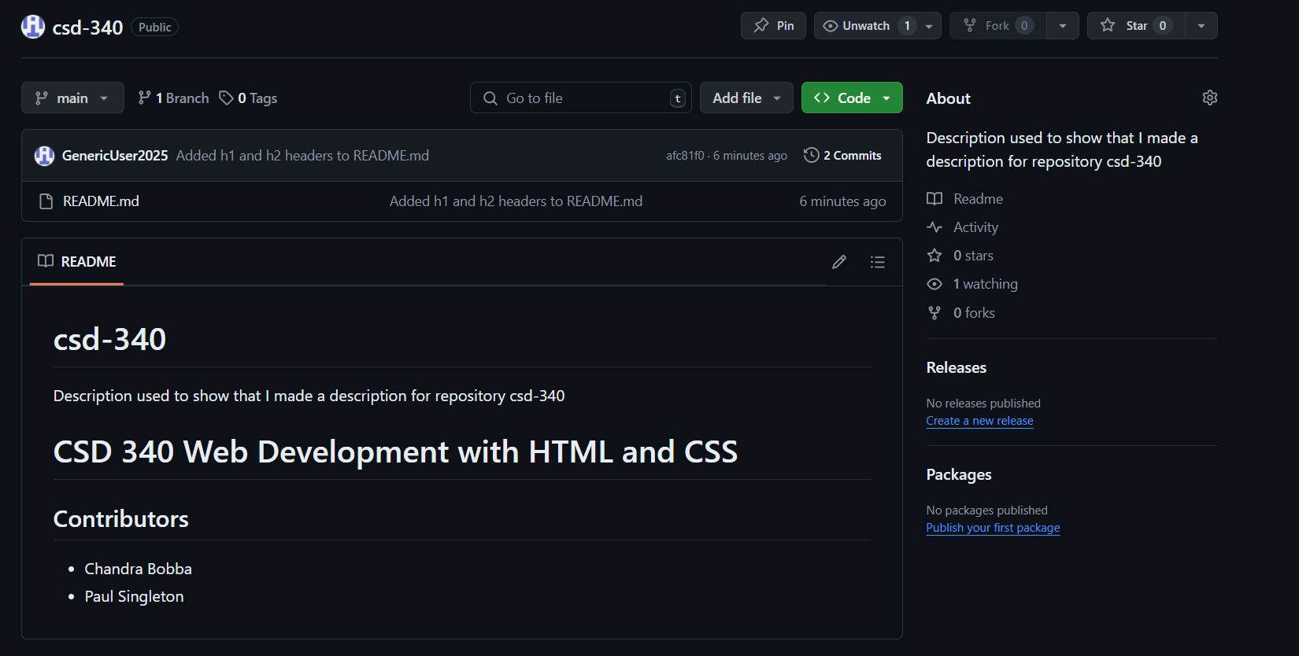

**Screenshot of Properly Formatted Directory in Main Branch:**

